**V8 BODY CAMERA**

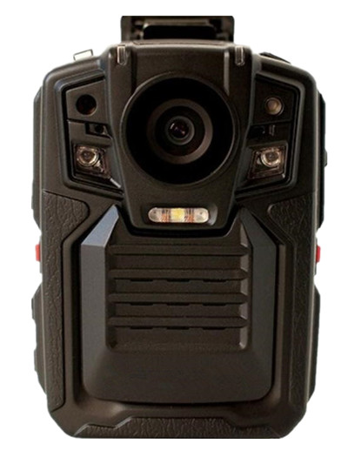

**USER MANUAL**

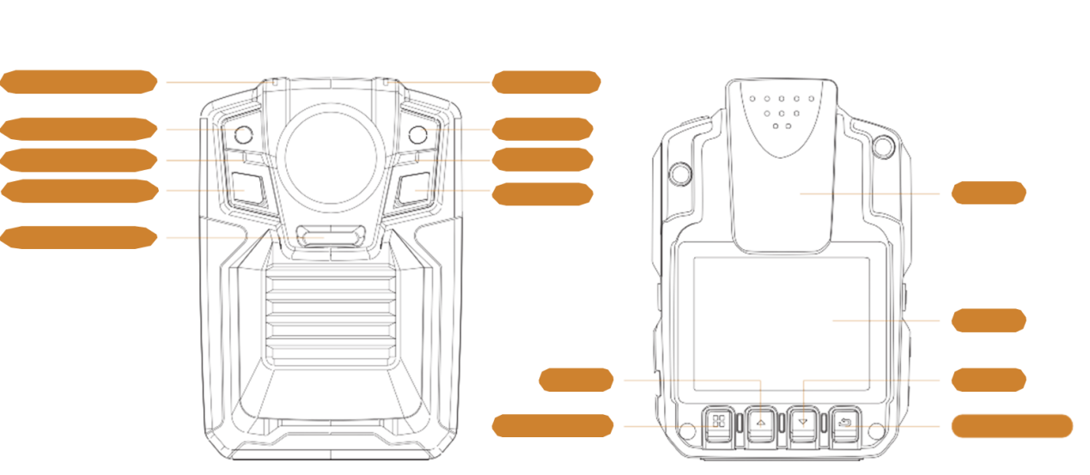

Playback/OK

MENU/Alarm

DOWN

UP

LCD

Clip

White lights

IR light

Microphone

Microphone

Laser light

Charging LED

IR light

Light sensor

Status LED

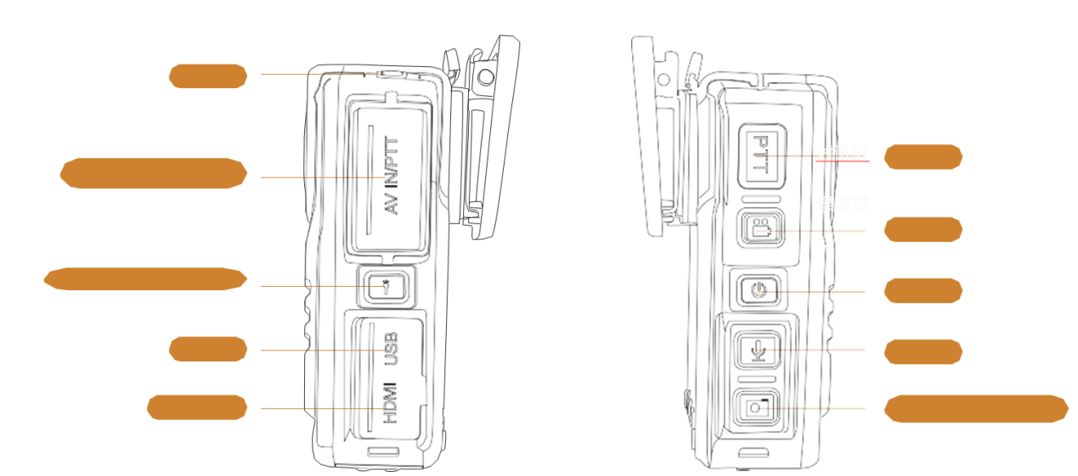

Photo/White light

Audio

Power

Video

PTT

HDMI port

USB port

Laser/IR lights button

Multifunction ports

Reset

> **Power button**--（Short press）In boot status, switch on/off LCD.

（Long press）2s to power on/off ；

> **Video button** --（Short press）In boot status, short press to start video recording, short press again to stop video recording, the videos will be saved automatically to storage.

> **Photo button** --（Short press）In standby status, short press to take pictures; While video recording, short press photo button can capture and save still pictures.

（Long press）Long press photo button to open white light, long press again to turn off white light.

> **Audio button** --（Short press）In standby status, short press to start audio only recording, short press again to stop audio only recording, audio files will be saved automatically to storage.

> **Laser/IR light** --（Short press）In standby status, short press to open laser light to posit location to ensure shooting direction is right.

（Long press）In standby status, long press to switch to IR night vision mode, camera can take night vision videos and take night vision pictures.

> **Multifunction ports**--（Connect）Connect to walkie talkie, external camera.

> **HDMI**--（Connect）Connect to HD monitor to view.

> **USB**-（Connect）Data transfer port, charging port；

**> Menu button--**（Short press）In standby status, short press to enter menu setting page, short press again to switch from VIDEO setting to PHOTO setting, short press OK to switch from PHOTO setting to system setting, short press again to exit setting page.

（Long press）In standby status, long press to enter alarm status, camera will release alarming sound and open alarming flash light；

> **UP button**--（Short press）In setting or selection status, it is UP selecting function; In video recording status, short press to mark important video, a yellow triangle mark icon will show up at

the left upper corner.

（Long press）In standby status or video recording status, long press to magnify the image, long press again to magnify again, can magnify to 16x.

> **DOWN button**--（short press） In setting or selection status, it is DOWN selecting function

（Long press）In standby status or video recording status, long press to minify the image, long press again to minify again, can minify to 16x ；

> **Playback/OK button**—（short press）In setting status, short press to confirm the selected.

（Long press）In standby status, long press to enter playback page; Short press to confirm the file selected, short press again to start playback the file. Long press again to exit the playback page.

**Main features**

> Powerful night vision function: in complete darkness, can see face outline in 10meters distance；

> Double filter switch: daytime no color cast, night time image clear；

> Strong security: No authorization, cannot read or delete recorded data；

> Stamp: there is date time and ID number stamp on each video and photo.

> Support external camera(AVIN)

> Super HD video：1296P；

> Pre-record and delay record；

> Record videos, take photos, record audio only；

> Can playback videos/photos/audio on camera display；

> Video files are saved by segments in case wrong operation cause losing data；

> Three operate reminders：LED、sound、vibration；

> Emergency alarming function；

> Important videos marking function.

**Specifications**

|  |  |
| --- | --- |
| Chipset：Ambarella A7LA50 | Split storage:5min/10min/20min/30min |
| Sensor:OV4689 | Pre-Record:20s-85s |
| Photo:32M(7552X4248 16:9) | Delay-Record:10s |
| (30M/23M/20M/18.5M/16M/4M) | Size:83mmx60mmx32mm |
| Video:2560*1080@30fps | Remote control:optional |
| [2304*1296@30fps](mailto:2304*1296@30fps) | Auto IR:menu available |
| [1920*1080@30fps](mailto:1920*1080@30fps) | Vibration:available |
| [1280*720@60fps/30fps](mailto:1280*720@60fps/30fps) | Display:2.0inch HD color display |
| [848*480@60fps/30fps](mailto:848*480@60fps/30fps) | Speaker:available |
| Storage:up to 128GB | Visual indicators:available |
| Battery life:6-8hours | Language:Multiple languages |
| GPS:built-in（optional） | Audio only record:support |
| Walkie-talkie:support | Encryption:password |
| Night vision:up to 15meters | Docking station software:available |
| Stamp:ID+date+time | Warranty:1year |
| Laser light:available | Battery MSDS:available |
| White light:available | External button lens:optional |
| Battery capacity:1950mahx2pcs(can change to be built-in battery, more than 2800mah) | Lens angle:140° |
| Drop resistant:3meters | OEM brand:support |
| Waterproof:IP65 | Accessories: drop-in-dock(optional), big clip, small clip, charger,  USB cable, car charger(optional), car mount(optional) |
| Port | USB, HDMI, AV in, PTT ,dock port |

Special functions:

1. Password protection

Users should install Ambarella driver on PC, use the background os software to access to the files in the encrypted camera. To use the background os, users need to know the login password. Detail instruction please refer to the CD.

1. PTT function

PTT is push to talk function, users connect the body camera with a walkie talkie(name it as A for example) via the customized walkie talkie cable through the PTT port on the camera. Then the body camera will play the role as a handheld microphone of the walkie talkie A. So once walkie talkie A is paired with any other walkie talkie, user can just push the PTT button on the camera to talk back to the paired walkie talkie without need of pushing the talk back button on itself. By this way, users can put the walkie talkie A on their belt or pocket, let the camera be the microphone and speaker. While users use this function, the camera can still work normally as a camera without any interfere, can still record videos, take photos, etc.

1. GPS tracking

The camera has built-in GPS function, first time to turn on the camera, please put it in open place to let it search GPS signal well, after GPS signal searched well, the red GPS icon on the LCD corner will turn green, the videos recorded will be along with GPS data. Then please use the GPS player to play back the GPS videos, you can see the map on the right side, video on the left side, and many other details in the player, please refer to the GPS player instruction in the CD.